September 12th, 2010
Hi
Not much to write about. I was rather tired so decided to do no exercise this week. Last Monday, I spent much of the day looking for, unsuccessfully, my US Social Security Card as Mummy needed it to get some kind of free insurance. I have no idea where I could have put it. I came across a Blue Cross insurance card from Stanford which had a 9-digit number that resembled an SSN. In all the looking, I managed to discover a copy of Gavin's SSN number – twice! Also, I discovered a copy of a form from about 7 years ago from the Stanford Alumni Association containing my particulars plus a Stanford alumni e-mail address. So, I looked up the address and yes, it works. It has quite a nice interface but the disadvantage is its storage capacity, which is only 25 MB; compare that with the 7500 MB which g-mail provides for each account. Anyway, for me that should not be a problem as I always keep the number of files in my e-mail accounts close to zero; for many I copy them to Word files before deleting.
On Wednesday evening there was a tremendous thunderstorm over many parts of HK, lasting from about 9 pm to 2 am the next morning. For some of that time I stood at the window watching the spectacular sound and light show. I checked the Observatory 'lightning strike' website and found that during that five-hour period there were about 34 100 strikes - ~26000 cloud to ground strikes and ~8100 cloud-to cloud 'strikes', i.e. about 113 strikes every minute!
As I have mentioned some time ago, I use the Google browser (Chrome). I discovered that that have their own pdf viewer as an option to Acrobat. I tested it by doing a search under 'matter' (chose this for no special reason but perhaps due to my science background) and opened the first pdf file on the list which happened to be about a conference co-sponsored by Northeastern University and CUHK (though the 'matter' in it had nothing to do with scientific matter). Nadine, you might like to open the file and see if you recognise the building in the picture on the first page:
http://www.baf.cuhk.edu.hk/mgt/download/Do%20Institutions%20Matter%20conference%20brochure.pdf
In an earlier e-mail to Gavin, I mentioned I have been trying to read a history book I inherited from Granddad called “The Works of Flavius Josephus”. Josephus was a first-century Romanised Jew (hence he changed his name from Joseph to the Roman form Josephus) who wrote a history of the Jewish people. The book is ~900 pages of very small print and is extremely difficult to read and comprehend. I was reading about the period from ~200 BC to ~100 AD. So I decided to read up instead from the Encyclopaedia Britannica books I still have - remember them? (And to think I was going to throw them away at one point. Using books rather than the internet to find informatio0n still has many advantages.) I looked up the history of Syria and Palestine but instead of beginning at ~200 BC, it began way back at the Palaeolithic (old stone) age so I decided to start from there. It has taken about two months but I have more or less finished. I have attached a copy of the timeline I prepared. I found this sort of history study much more interesting that the way history was taught when I was at school, especially as I also have recordings (from TV) of events that took place during this period. I have now gone back to reading 'Josephus' and it is (a bit) easier to follow and understand. Save the copy of my history file and read it sometime (ignoring the few errors I have since found it it).
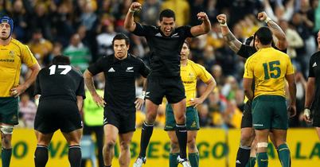
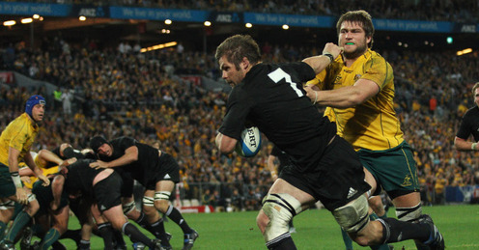
The last Tri-Nations test was held yesterday in Sydney between NZ and Australia, with the ABs winning, having been down 22-9 with just 15 minutes left. So the ABs won all six of their Tri-Nations matches, Australia two and SA just one. Last weekend, the NZ women's team won their fourth consecutive Women's RWC title, beating England 13-10 in final. The fourth Bledisloe Cup match (NZ-Aus only), which was held in HK two years ago, is supposed to be held again here next month. But as only about 10 000 tickets have been sold, and despite statements to the contrary, it is possible that the venue may be shifted to London.
Last night, on BBC TV, I watch the initial part of the 9/11 ceremony in New York. It seems to have been played up a bit more than in previous years, even though it is only the 9th anniversary; usually events are remembered more at 5- or 10-year anniversaries.
That seems to be it for now.
Cheers

